|  |  |  |
| --- | --- | --- |
| SCHOOL OF INFORMATION AND TECHNOLOGY | | |
| NAME: Zhaun Gabrielle F. Pasion | DATE PERFORMED: 12/9/24 |  |
| Section: IDC2 | DATE SUBMITTED: 12/9/24 |

# SYSADM1 – Managing Services in Linux

# Requirement:

* A virtual machine running Linux

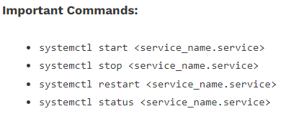

Complete this lab as follows:

Use the service –status-all command to list all active and inactive services.

List down active and inactive services in the table below. Provide five (5) services for each column.

|  |  |
| --- | --- |
| **Active** | **Inactive** |
| alsa-utils | anacron |
| apport | apparmor |
| cron | bluetooth |
| cups | console-setup.sh |
| dbus | cryptisks |

SS:

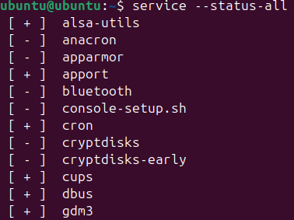

Start the Bluetooth service using the systemctl command.

Ex. sudo systemctl start httpd



Check the status of the Bluetooth service. What is its status? inactiveSS:

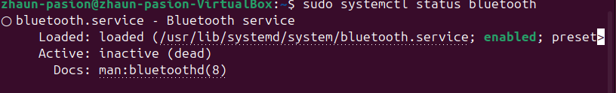

Check the status of the cups services. Since when was it running?

Active since 2024-9-12 09:09:14 4min 36 s ago

SS: 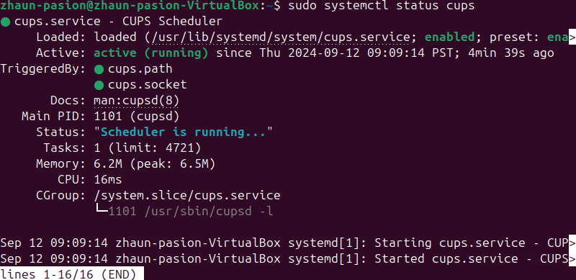

Stop cups services.





Verify if the service was stopped.

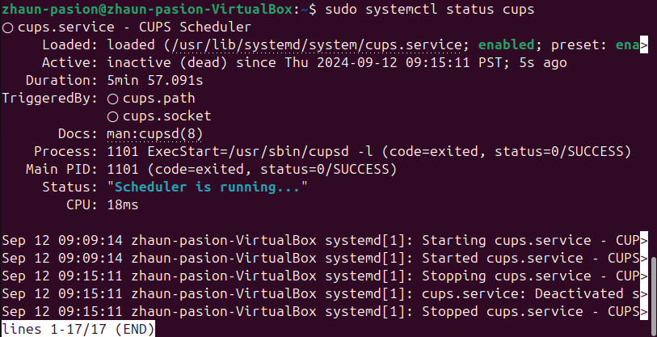

Restart the cups services



Verify if the service was restarted.



